|  |
| --- |
| Logbook for ISD |
| Your name and student number |
|  |
|  |
|  |

Logbook for ISD

Your name and student number

Contents

Introduction 2

Week 1 3

Exercises 1 3

Exercises 2 3

Exercises … 3

Week 2 4

Exercises 1 4

Exercises 2 4

Exercises … 4

Week 3 5

Exercises 1 5

Exercises 2 5

Exercises … 5

Week…13 6

Exercises 1 6

Exercises 2 6

Exercises … 6

# Introduction

A brief introduction to what you have done within the module and how your experience was with the exercises and the overall module. Probably up to half a page.

Week 3

Some overview of the topics covered by the lecture and the exercises. Not too much, may be a paragraph.

## Exercises: 1

## Write a program that asks for two numbers (Python has all the basic mathematical functions in place, like +,- etc.), adds them up and displays the result

Answer:

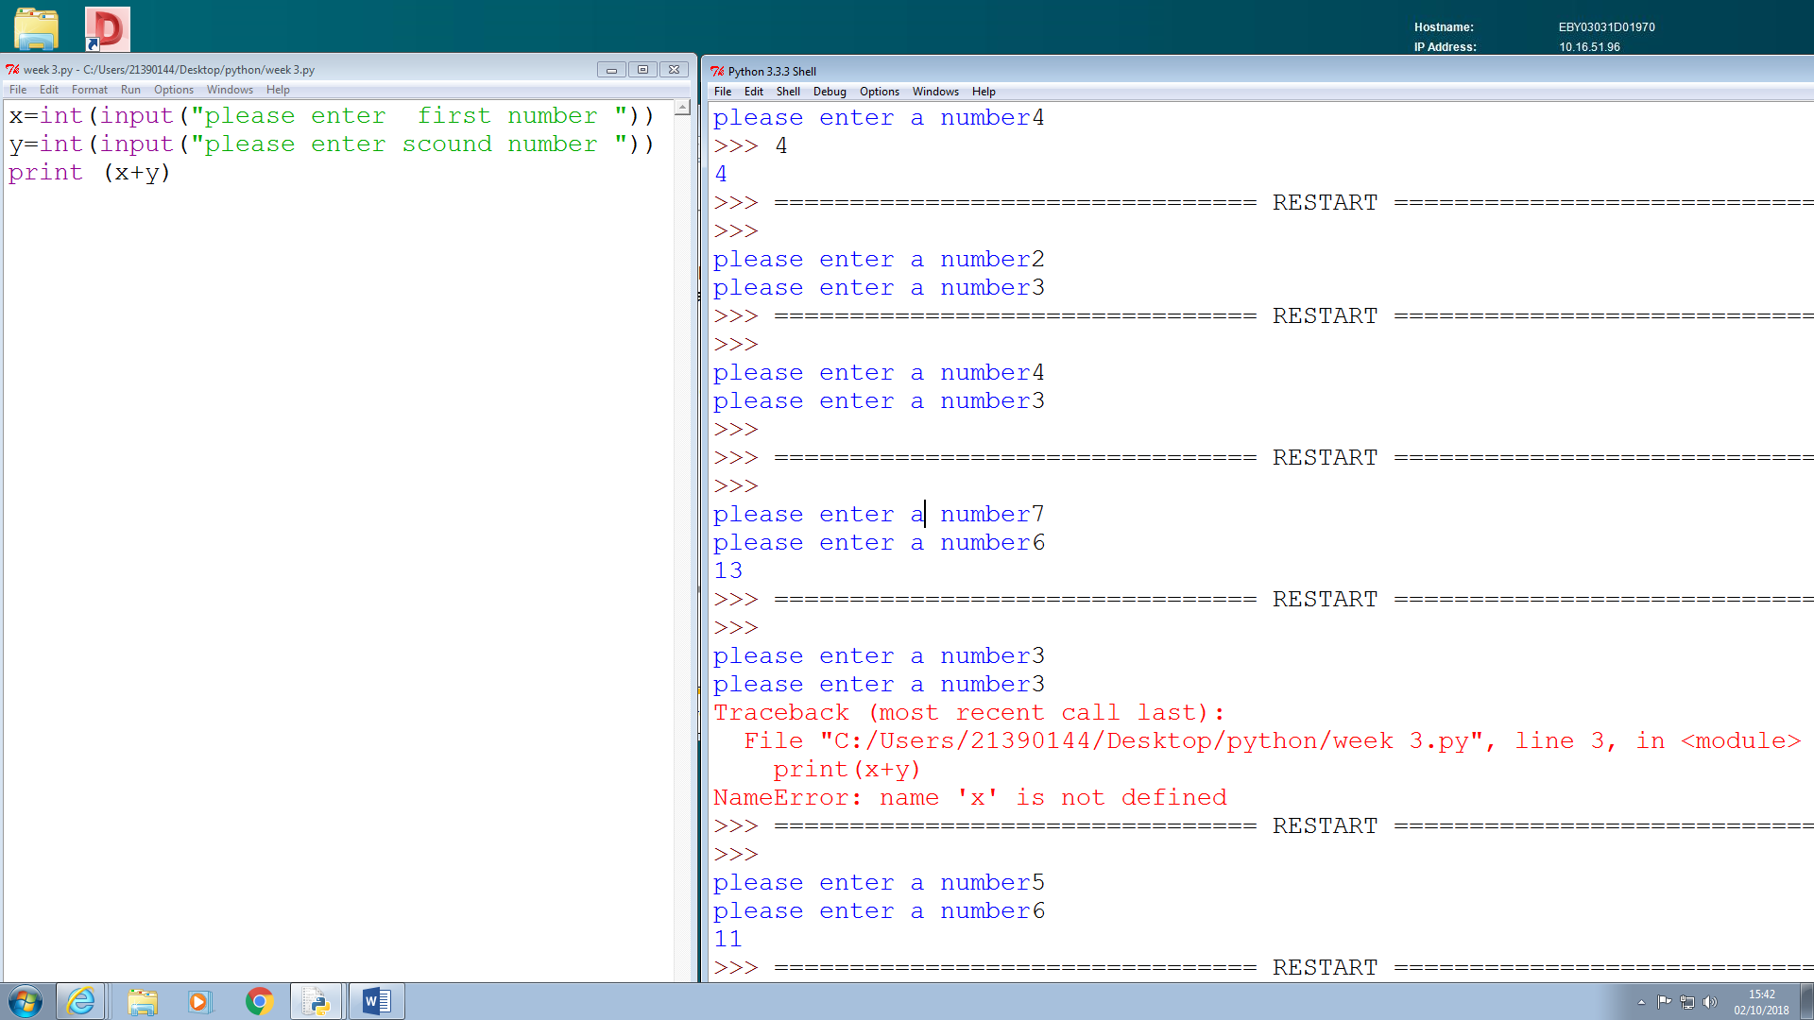

## Exercises 2

1. a) What will the output be from the following code?

num = 4

num*=2

num1=num+2

num1+=3

## print(num1)

Answer A

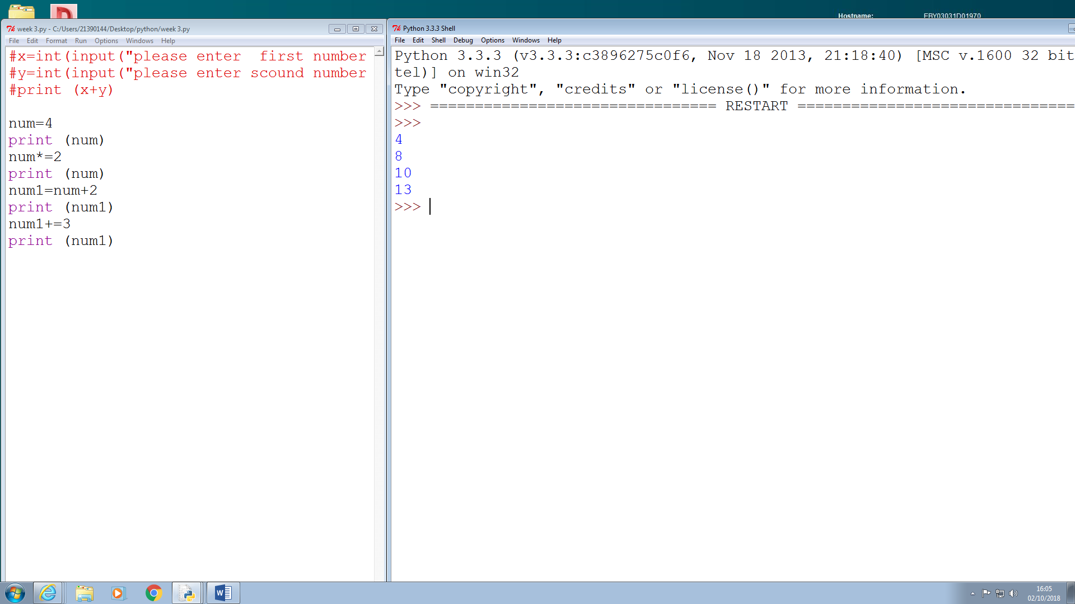

1. B) What do the following lines of code output? Why do they give a different answer?

print(2 / 3)

print(2 // 3)

Answer B

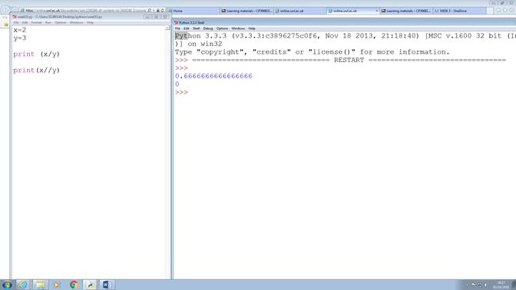

Exercises 3

All of the variable names below can be used. But which of these is the better variable name to use?

A a Area AREA area areaOfRectangle AreaOfRectangle

Answer:

areaOfRectangle

Exercises 4

Which of these variables names are not allowed in Python? (More than one might be wrong.)

apple APPLE Apple2 1Apple account number account_number account.number accountNumber fred Fred return return_value 5Return GreatBigVariable greatBigVariable great_big_variable great.big.variable

answer:

1Apple

account number

account.number

return_value

5Return

great.big.variable

Example description of an exercise:

